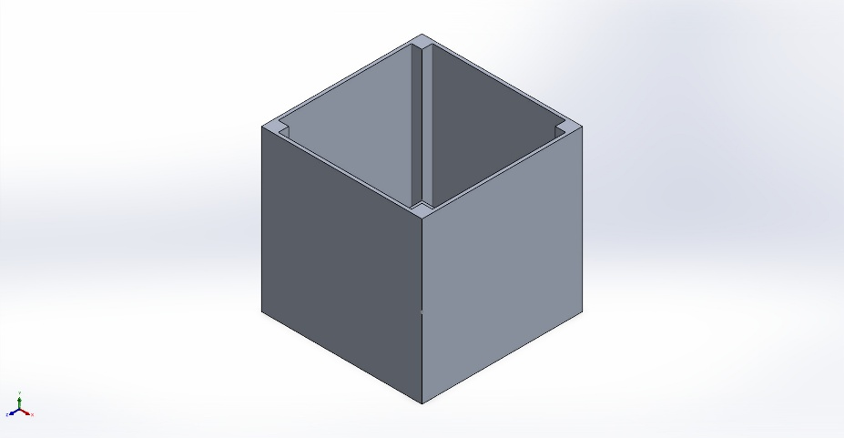 | Simulation of CUBESATPROJECT  Date: Friday, August 7, 2026  Designer: Solidworks  Study name: Static 1  Analysis type: Static  Table of Contents  Description 1  Assumptions 2  Model Information 2  Study Properties 3  Units 3  Material Properties 4  Loads and Fixtures 4  Connector Definitions 5  Interaction Information 5  Mesh information 6  Sensor Details 7  Resultant Forces 8  Beams 8  Study Results 9  Conclusion 11

Description
No Data

Assumptions

Model Information

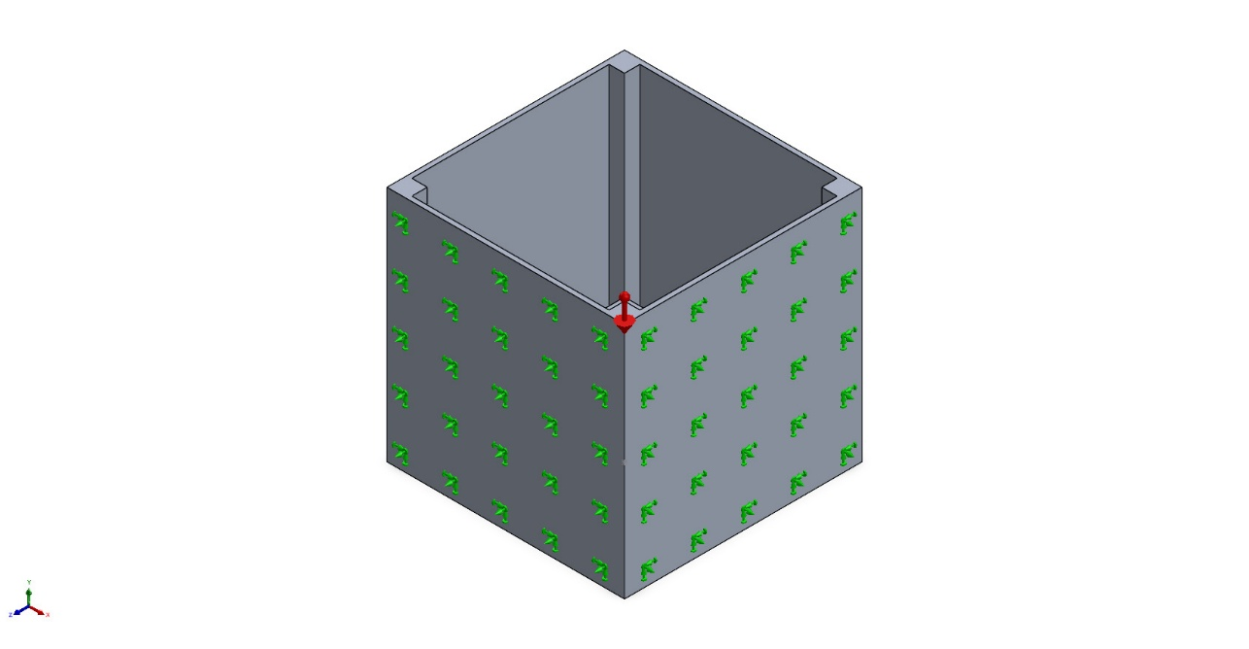
Model name: CUBESATPROJECT
Current Configuration: Default
Solid Bodies
Document Name and Reference | Treated As | Volumetric Properties | Document Path/Date Modified
Boss-Extrude2  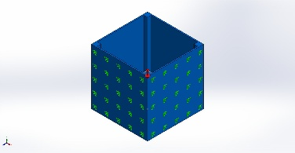 | Solid Body | Mass:0.25731 kg  Volume:9.53e-05 m^3  Density:2,700 kg/m^3  Weight:2.52164 N | C:\Users\frxif\OneDrive\Documents\CUBESATPROJECT.SLDPRT  Aug 6 16:11:20 2026
Boss-Extrude3  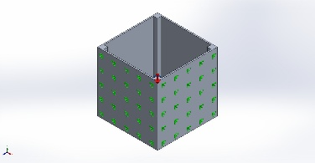 | Solid Body | Mass:0.0343863 kg  Volume:1.27357e-05 m^3  Density:2,700 kg/m^3  Weight:0.336986 N | C:\Users\frxif\OneDrive\Documents\CUBESATPROJECT.SLDPRT  Aug 6 16:11:20 2026

Study Properties
Study name | Static 1
Analysis type | Static
Mesh type | Solid Mesh
Thermal Effect: | On
Thermal option | Include temperature loads
Zero strain temperature | 298 Kelvin
Include fluid pressure effects from SOLIDWORKS Flow Simulation | Off
Solver type | Automatic
Inplane Effect: | Off
Soft Spring: | Off
Inertial Relief: | Off
Incompatible bonding options | Automatic
Contact penalty stiffness scale factor | 1
Large displacement | Off
Compute free body forces | On
Friction | Off
Use Adaptive Method: | Off
Result folder | SOLIDWORKS document (C:\Users\frxif\OneDrive\Documents)

Units
Unit system: | SI (MKS)
Length/Displacement | mm
Temperature | Kelvin
Angular velocity | Rad/sec
Pressure/Stress | N/m^2

Material Properties
Model Reference | Properties | Components
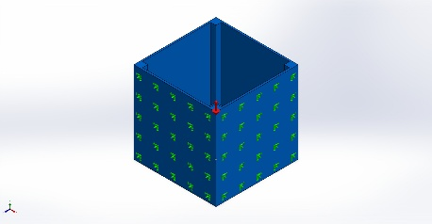 | Name: 6061-T6 (SS)  Model type: Linear Elastic Isotropic  Default failure criterion: Unknown  Yield strength: 2.75e+08 N/m^2  Tensile strength: 3.1e+08 N/m^2  Elastic modulus: 6.9e+10 N/m^2  Poisson's ratio: 0.33  Mass density: 2,700 kg/m^3  Shear modulus: 2.6e+10 N/m^2  Thermal expansion coefficient: 2.4e-05 /Kelvin | SolidBody 1(Boss-Extrude2)(CUBESATPROJECT),  SolidBody 2(Boss-Extrude3)(CUBESATPROJECT)
Curve Data:N/A

Loads and Fixtures
Fixture name | Fixture Image | Fixture Details
Fixed-1 | 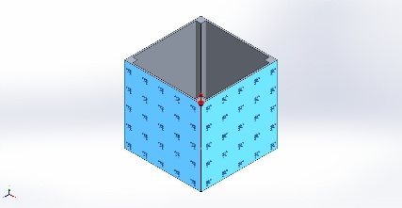 | Entities: 4 face(s)  Type: Fixed Geometry
Resultant Forces
Components | X | Y | Z | Resultant
Reaction force(N) | -6.64717e-07 | 28.5863 | 9.26666e-07 | 28.5863
Reaction Moment(N.m) | 0 | 0 | 0 | 0

Load name | Load Image | Load Details
Gravity-1 | 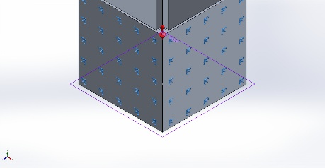 | Reference: Top Plane  Values: 0 0 -98  Units: m/s^2

Connector Definitions
No Data

Interaction Information

Interaction | Interaction Image | Interaction Properties
Local Interaction-1 | 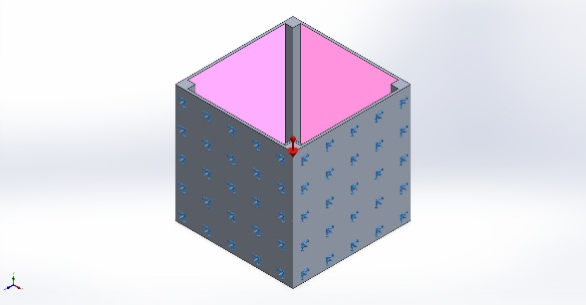 | Type: Bonded interaction pair  Entities: 8 face(s)
Global Interaction | 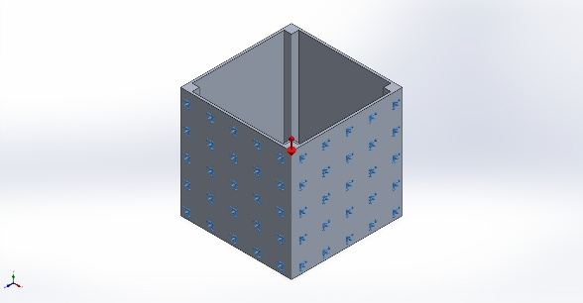 | Type: Bonded  Components: 1 component(s)  Options: Independent mesh

Mesh information
Mesh type | Solid Mesh
Mesher Used: | Blended curvature-based mesh
Jacobian points for High quality mesh | 16 Points
Maximum element size | 12.2482 mm
Minimum element size | 1.22459 mm
Mesh Quality | High

Mesh information - Details
Total Nodes | 6879
Total Elements | 3244
Maximum Aspect Ratio | 9.5185
% of elements with Aspect Ratio < 3 | 39.1
Percentage of elements with Aspect Ratio > 10 | 0
Percentage of distorted elements | 0
Time to complete mesh(hh;mm;ss): | 00:00:01
Computer name: | BATMOBILE

Mesh Quality Plots
Name | Type | Min | Max
Quality1 | Mesh | - | -
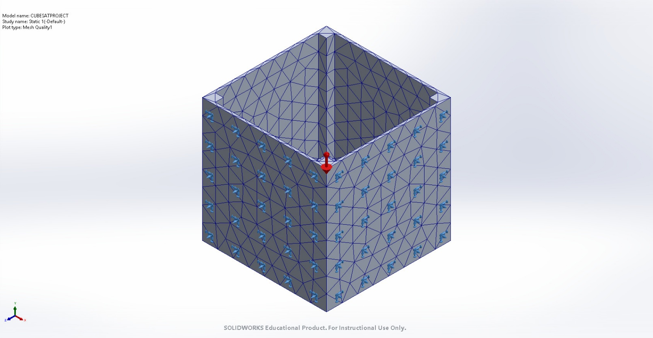
CUBESATPROJECT-Static 1-Quality-Quality1

Sensor Details
No Data

Resultant Forces

Reaction forces
Selection set | Units | Sum X | Sum Y | Sum Z | Resultant
Entire Model | N | -6.64717e-07 | 28.5863 | 9.26666e-07 | 28.5863

Reaction Moments
Selection set | Units | Sum X | Sum Y | Sum Z | Resultant
Entire Model | N.m | 0 | 0 | 0 | 0

Free body forces
Selection set | Units | Sum X | Sum Y | Sum Z | Resultant
Entire Model | N | 4.84288e-08 | 18.1968 | 2.21655e-07 | 18.1968

Free body moments
Selection set | Units | Sum X | Sum Y | Sum Z | Resultant
Entire Model | N.m | 0 | 0 | 0 | 1e-33

Beams
No Data

Study Results

Name | Type | Min | Max
Stress1 | VON: von Mises Stress | 1.133e-01N/m^2  Node: 2030 | 1.582e+05N/m^2  Node: 3833
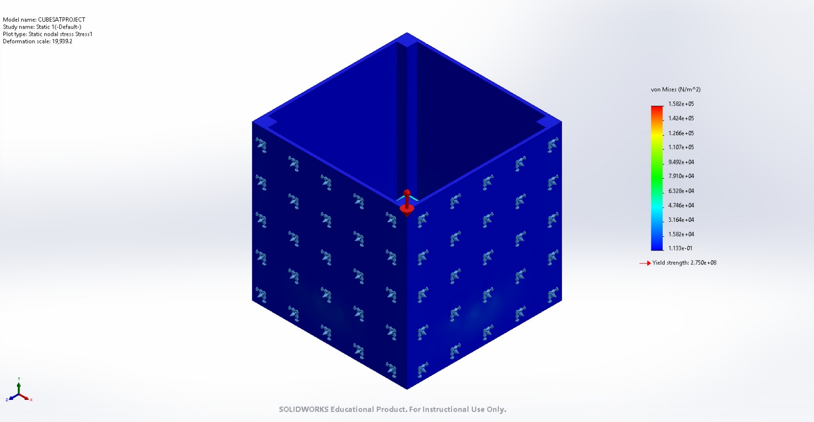
CUBESATPROJECT-Static 1-Stress-Stress1

Name | Type | Min | Max
Displacement1 | URES: Resultant Displacement | 0.000e+00mm  Node: 1 | 5.015e-04mm  Node: 6543
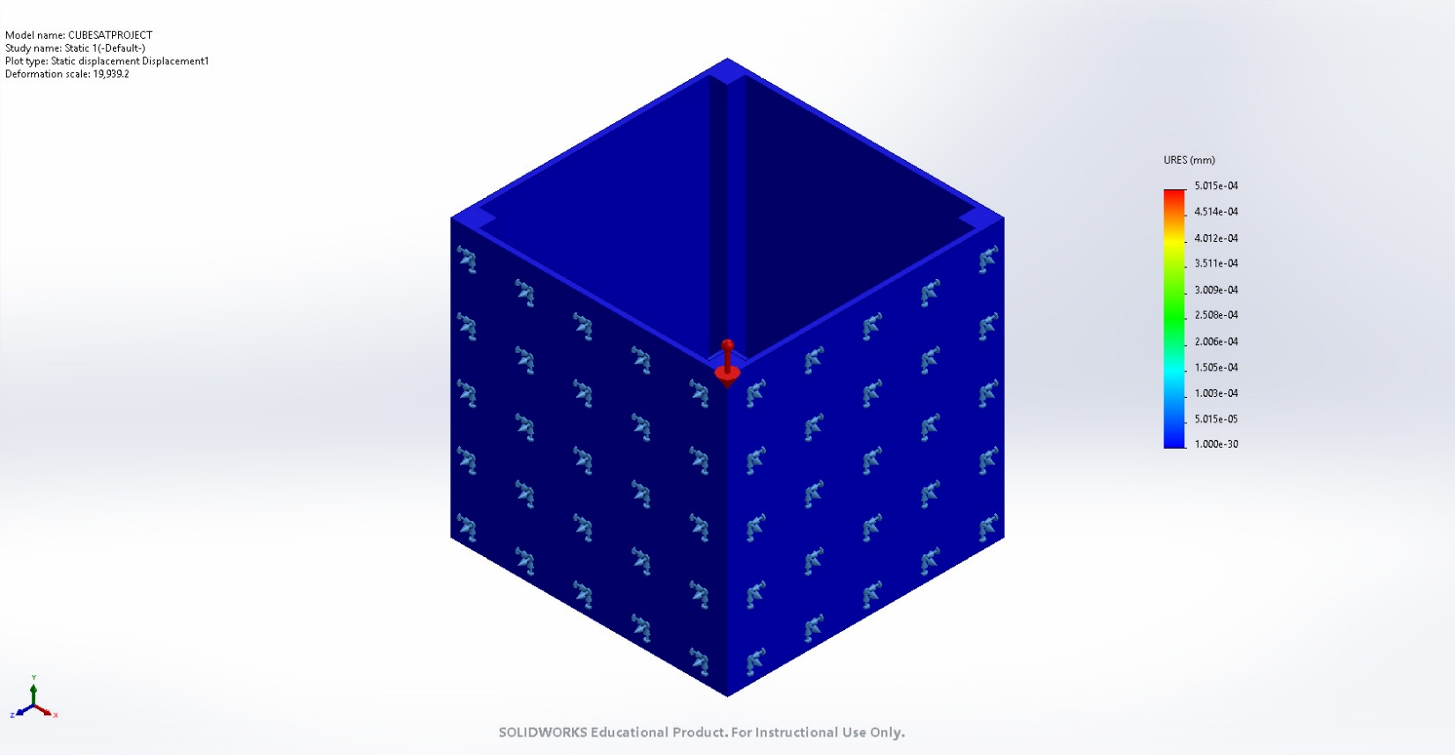
CUBESATPROJECT-Static 1-Displacement-Displacement1

Name | Type | Min | Max
Strain1 | ESTRN: Equivalent Strain | 1.829e-09  Element: 669 | 1.316e-06  Element: 3204
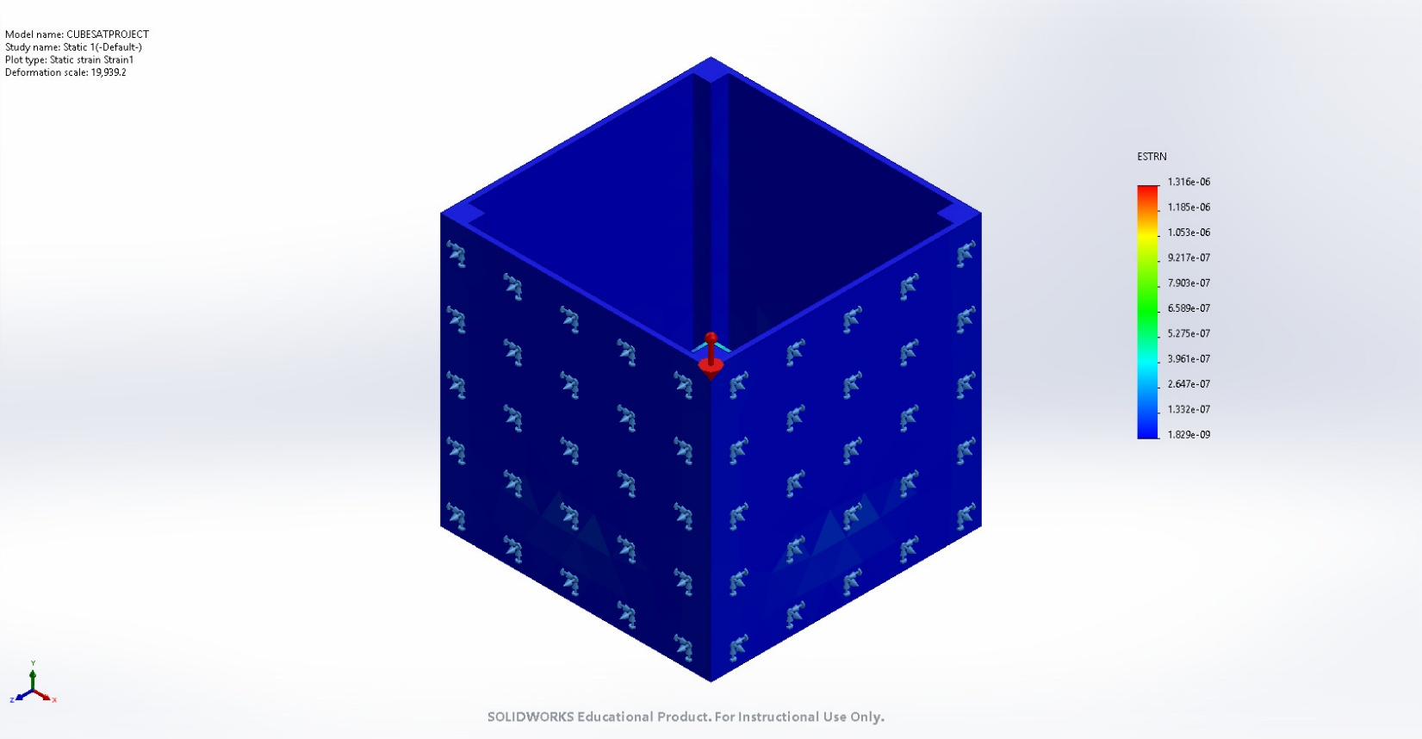
CUBESATPROJECT-Static 1-Strain-Strain1

Conclusion

